# What is What

**What is What**

## Overview

*Overview of User interface and how it communicates with another layer/interface.*

## Splash Page

### Interface



[Figure 1]

### Description

*This is the Splash Screen of Application, it is displayed when the screen launches*

## Login Page

### Interface

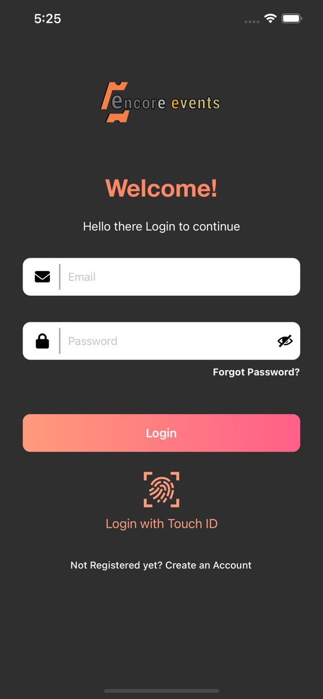

[Figure 3]

### Description

*This is the login screen, where user will add his valid email and password for further login. This screen will be displayed when user opens the app for first time and also in case user is not logged in to the application*

## Company Registration Page

### Interface

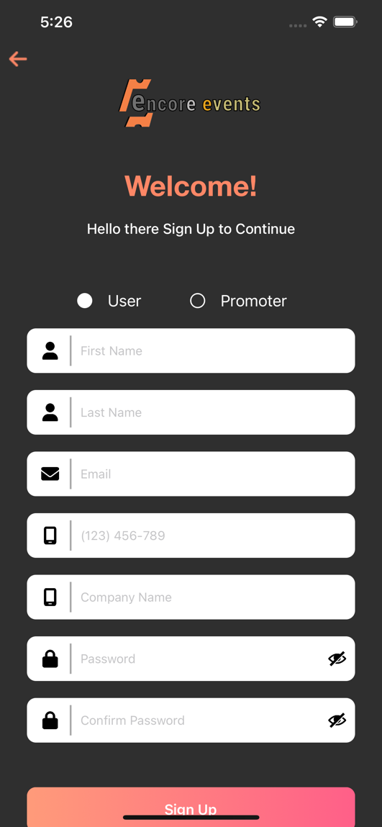

[Figure 2]

### Description

*This is screen will appeares when user choose fro signup with the application from login screen.If we sign up in the application user can get the confirmation mail to register email-id after confirmation we are able to login into the application.*

## Forgot Password Page

### Interface

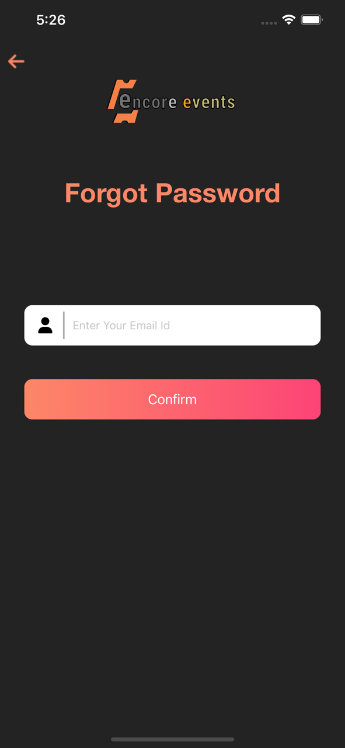

[Figure 5]

### Description

*This screen would be used, if user forget his password. User need to enter his registered email-id to get the OTP. After that [Figure 6], screen would appear to change the password.*

## Forgot Password Page

### Interface

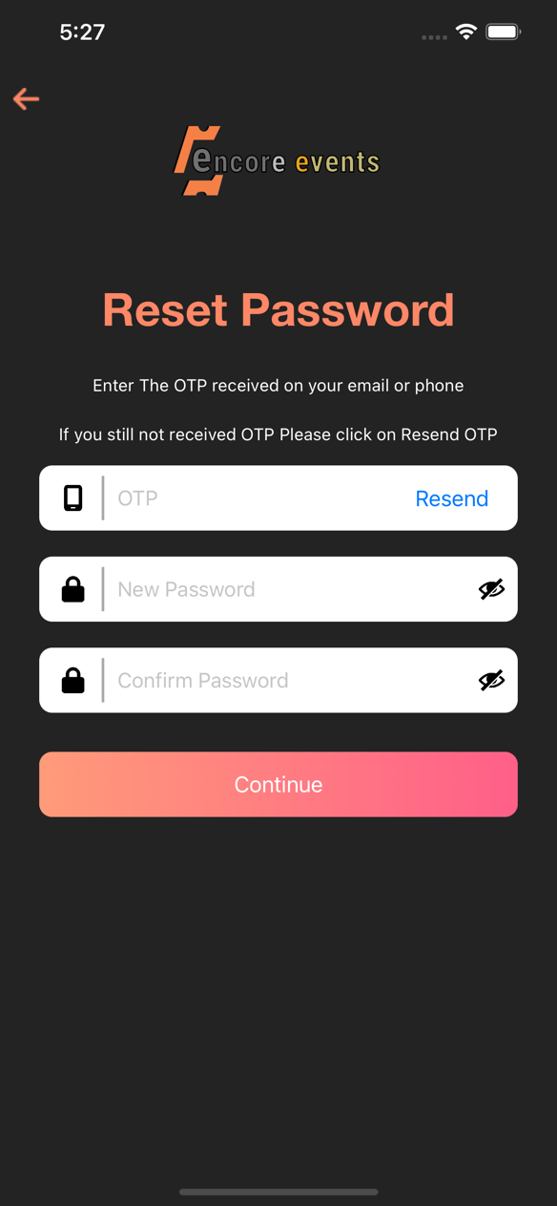

[Figure 6]

### Description

*This screens would be used, verify otp and set new password.*

## SideMenu Page

### Interface

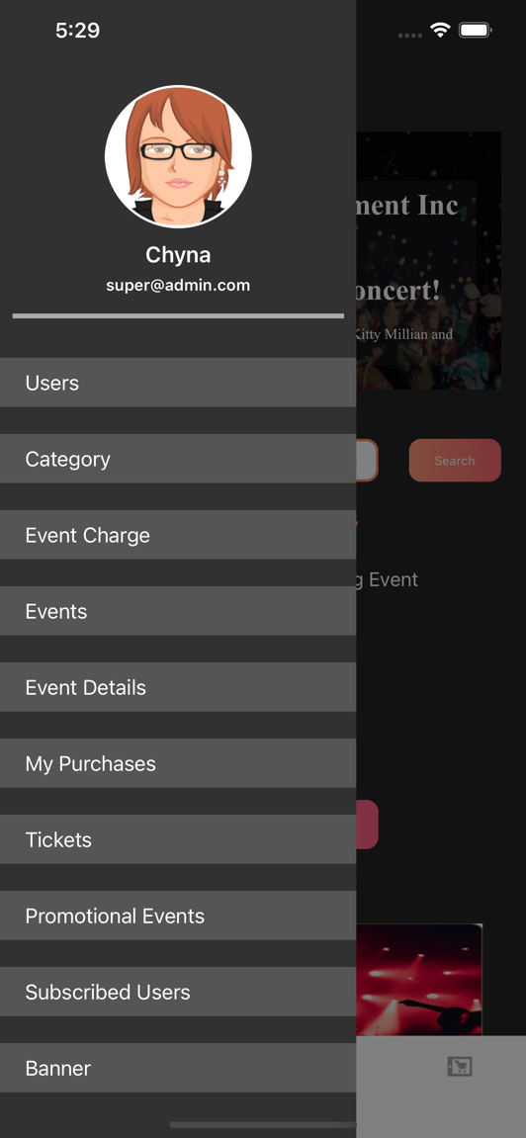

[Figure 7]

### Description

Above is Side Menu page of the application.it has multiple task to be performed like logging out , create ticket, create event, add banner, Promotional list and scanner functionality.we also showing the profile picture of user and his/her email id. All Modules of application is appear here.

## Profile Page

### Interface

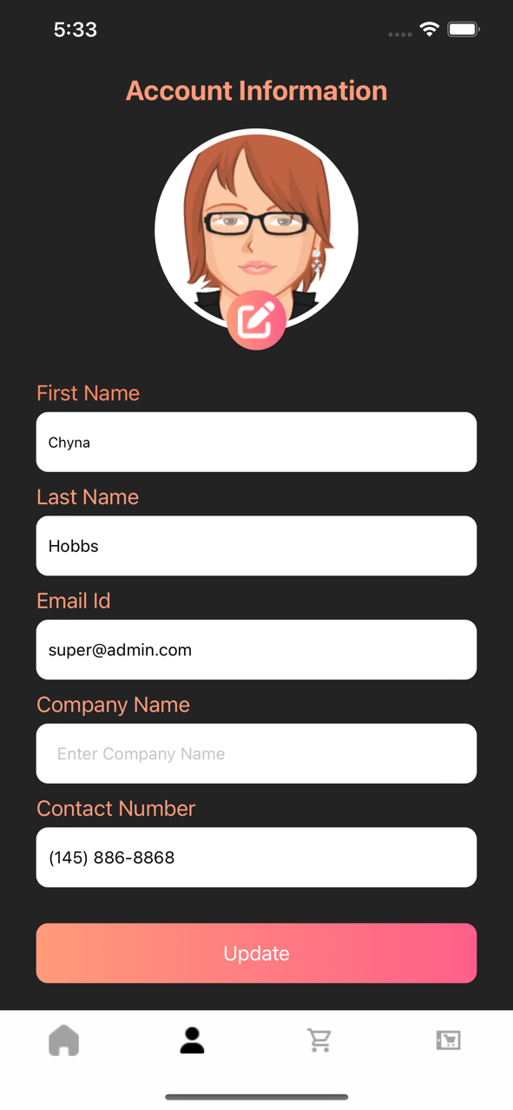

[Figure 7]

### Description

Above is user profile screen with user details. is used see the screen like this screen is used to display the information of account holder here the user can change their profile name, contact number and company name. Email id is not editable.

## Edit Profile Page

### Interface

**

[Figure 7]

### Description

Above is the Edit User Profile of the application. Its is used to edit personal info added during signup. It is used see the screen like this screen is used to display the information of account holder here the user can change their profile name, contact number and company name. Email id is not editable.

## Home Screen

### Interface

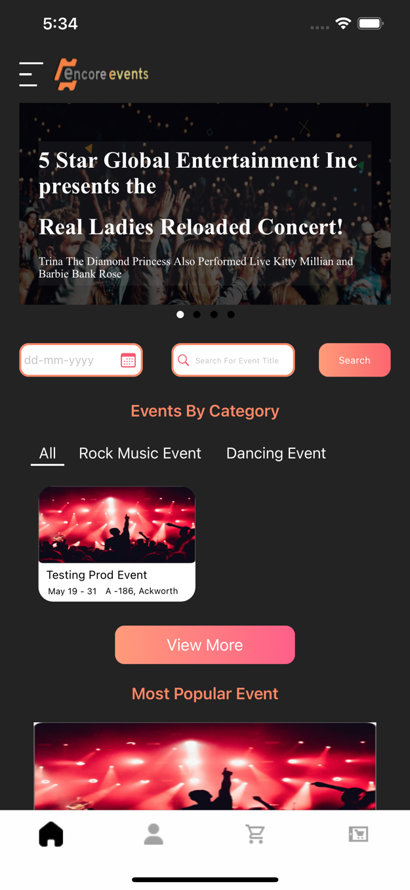

[Figure 7]

### Description

Above is Home Screen of the application. This screen is showing the event details. This screen is visible to user with or without signup if user want to buy a ticket for a event he need to login into application. Home screen contains banner image, event category, most popular event and company address.

## Events Page

### Interface

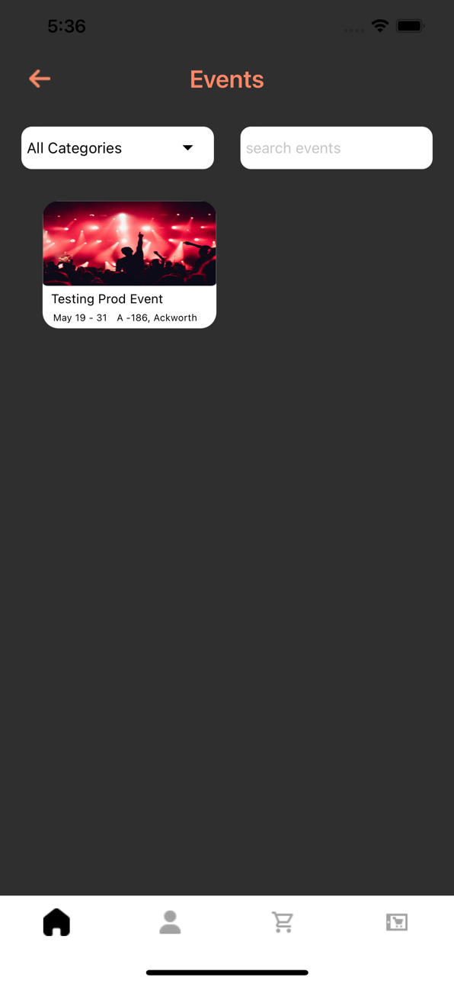

[Figure 7]

### Description

Above is Event page of the application.it is used to display the list of all event here the user can filter the event according to event categories. This screen shows the all evengt details of event here we search the event by name or by event category.

## Manage User Page

### Interface

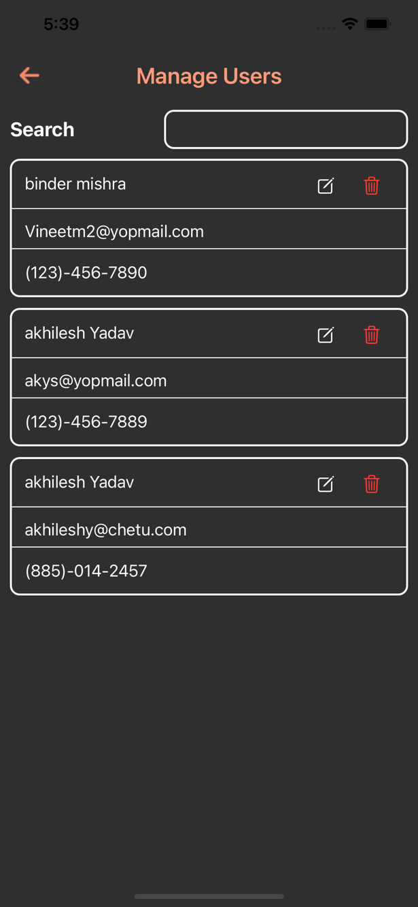

[Figure 7]

### Description

Above is Manage user page of the application. Its is used to show the user information who can create the account in application. We can delete and edit the user details in manage user screen.

This screen shows the user email-Id, Phone number and name.

## Manage Promoter Page

### Interface

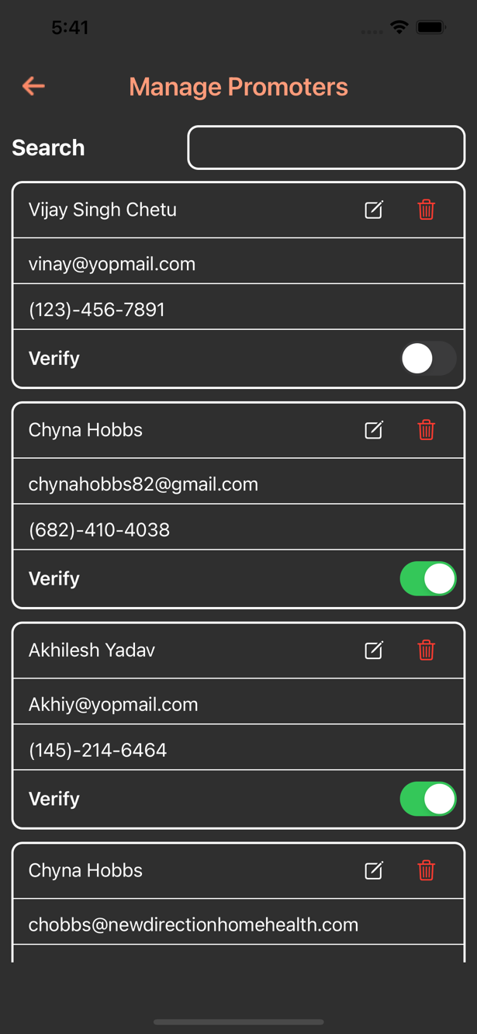

[Figure 7]

### Description

Above is Manage Promoter page of the application. This screen is used to show the list of Promoter. This screen is used to edit and delete the promoter. This screen is used to verify the promoter for own company. This screen is only for Admin.

## Update user Page

### Interface

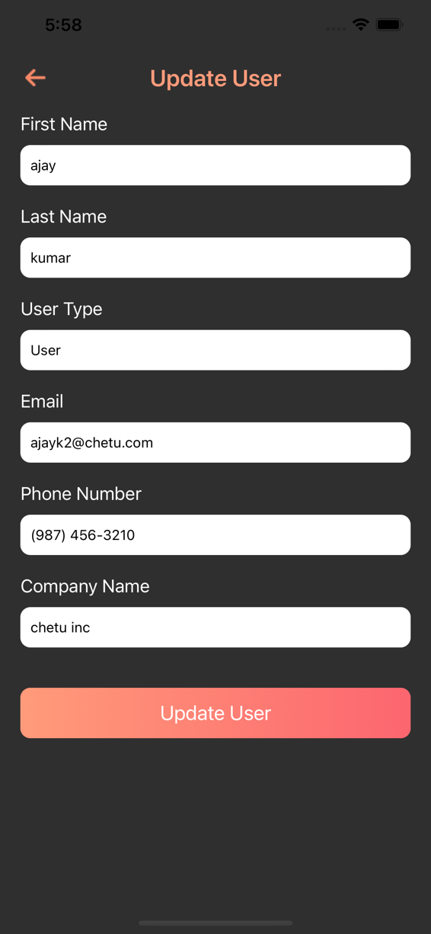

[Figure 4]

### Description

Above is the update user page of the application.This screen is used to update the user details.All the field is required for update the user information. This screen contains Name, email, phone number and company name. If we update user the updated details is showing manage User screen.

## Update Promoter Page

### Interface

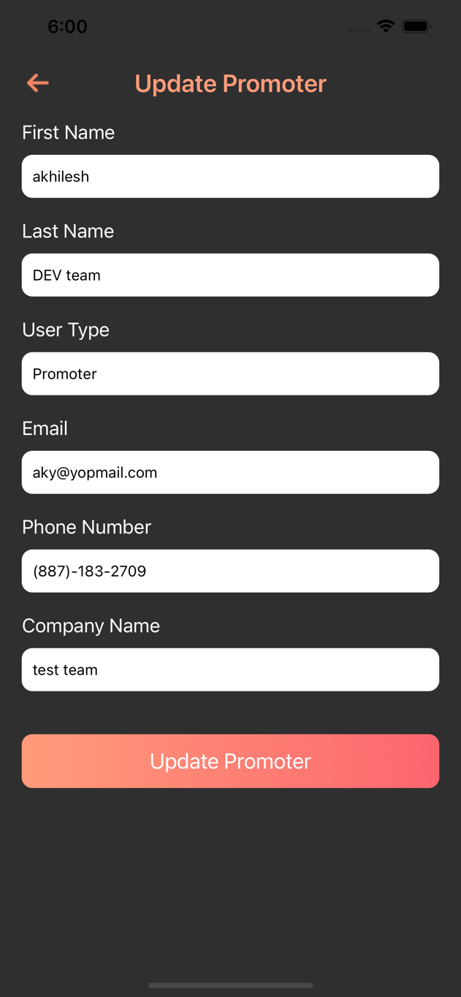

[Figure 4]

### Description

Above is the update Promoter page of the application.this screen is used to update the Promoter details. All the field is required for update the Promoter information. This screen contains Name, email, phone number and company name. If we update promoter the updated details is showing manage Promoter screen.

## Add Category Page

### Interface

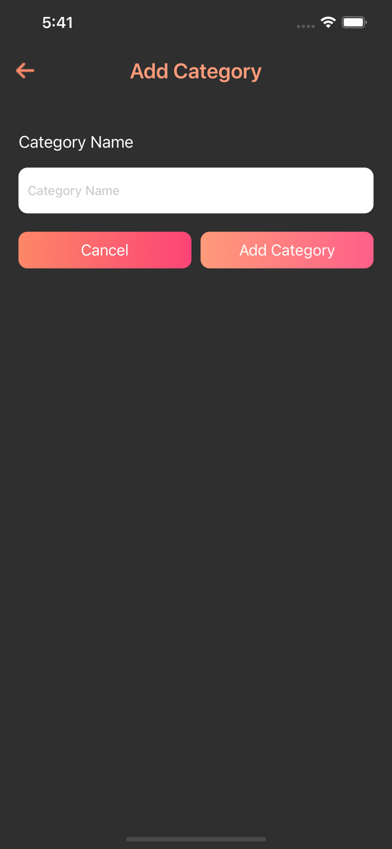

[Figure 4]

### Description

Above is Add Catehory page of the application. This screen is used to add category in home screen for event. This category manage the event if we create a event we need to choose category for event.

## Manage Category Page

### Interface

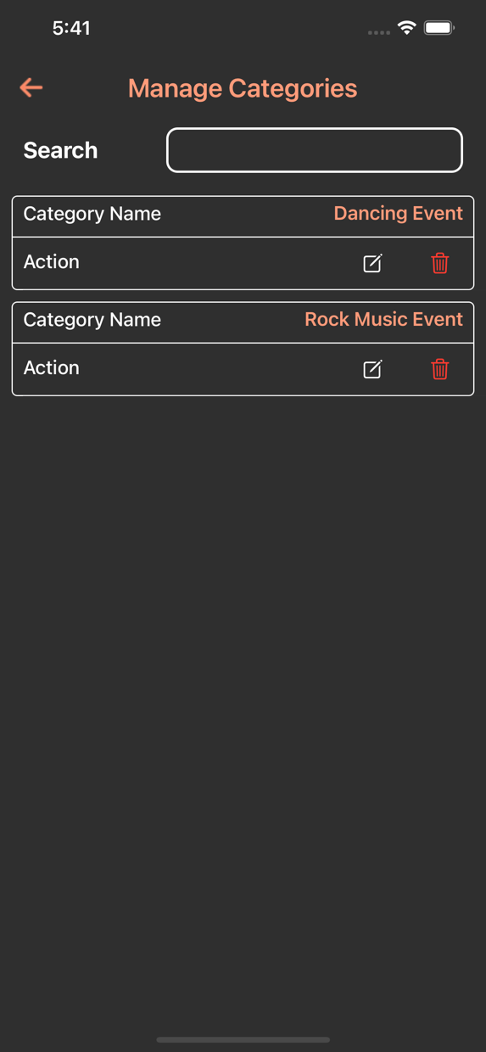

[Figure 4]

### Description

Above is Manage Catehory page of the application. This screen is used to manage the category detais. We can delete and update the catory in this screen. This screen showing the Category name Category name is required for identify the event belongs to which category.

## Update Category Page

### Interface

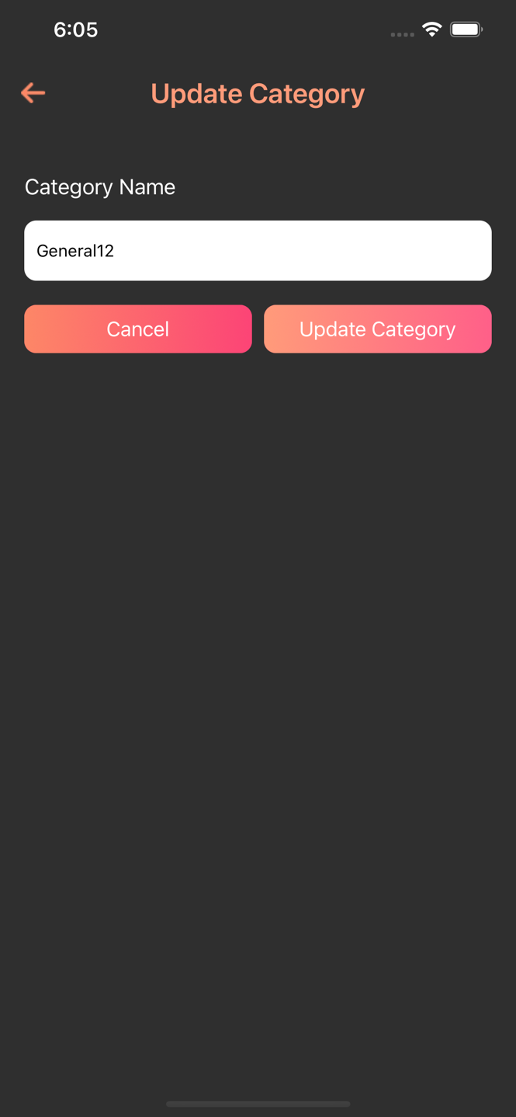

[Figure 4]

### Description

Above is Update Category page of the application. This screen is used to update the category. This category manage the event if we create a event we need to choose category for event. This screen is used for update event category.

## Update Event Charge Page

### Interface

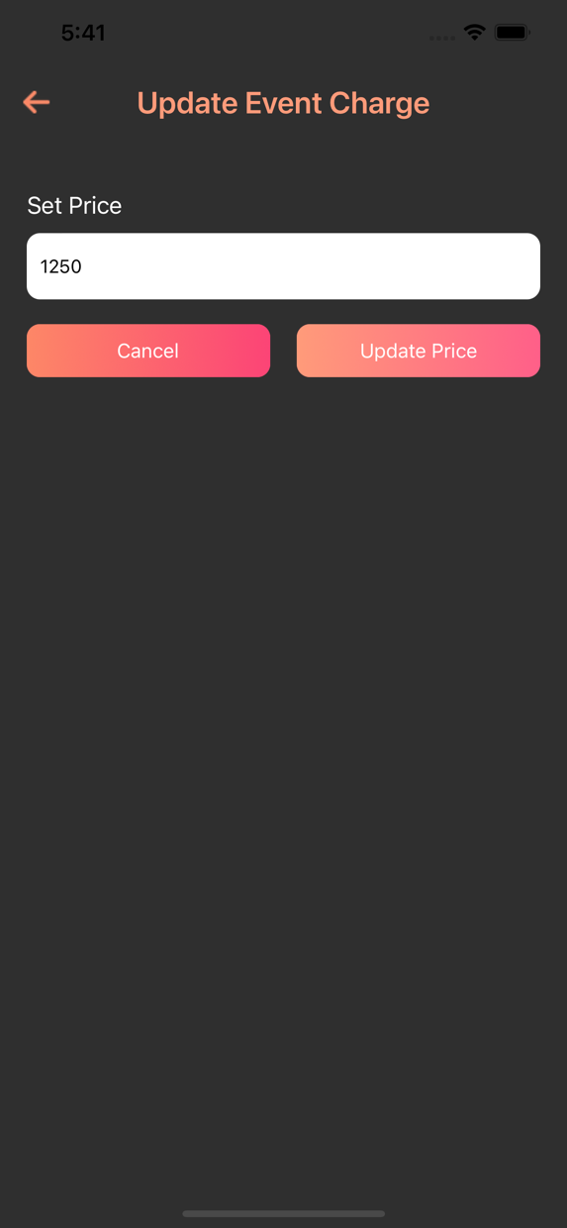

[Figure 4]

### Description

Above is Update Event Chagre page of the application. You can change the event price with this screen and the update charge is showing in manage event screen.This amount is change dynamically for all event. This functionality is for Admin and Promoter and the charge is applicable for other Promoter if admin verify the promoter so promoter can make event free.

## Create Event Page

### Interface

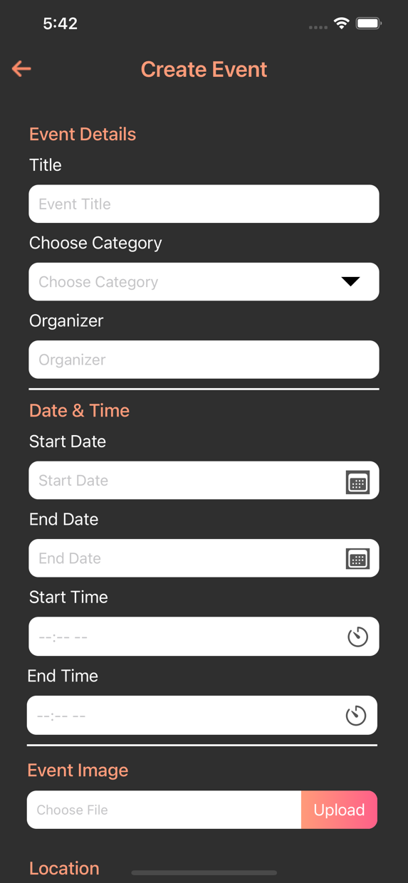

[Figure 4]

### Description

Above is Create event page of the application. For this screen you create a event for creating event you can fill the required filed on click of save event your event is created. In create event screen we need to enter start date and end date for event.Here we list out all the information like zipcode, address, state, organizer, event title and start/end date.

## Manage Event Page

### Interface

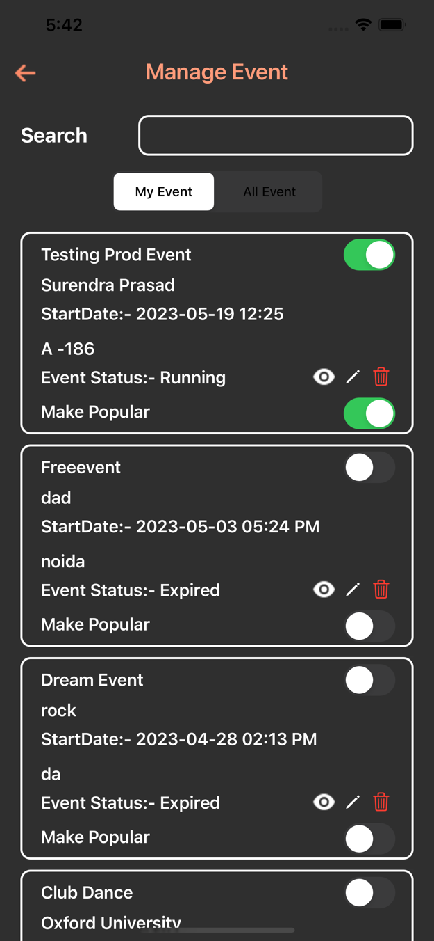

[Figure 4]

### Description

Above is manage event page of the application. Here we can see the all event details for self and different promoter’s event . We can also change the staus of event to live the event and make popular the event if we can change the status of event the live event is shown in event category and popular event is showun in most popular event in home screen.we can see the event detais edit event details and also delete event.

## Event Detail Page

### Interface

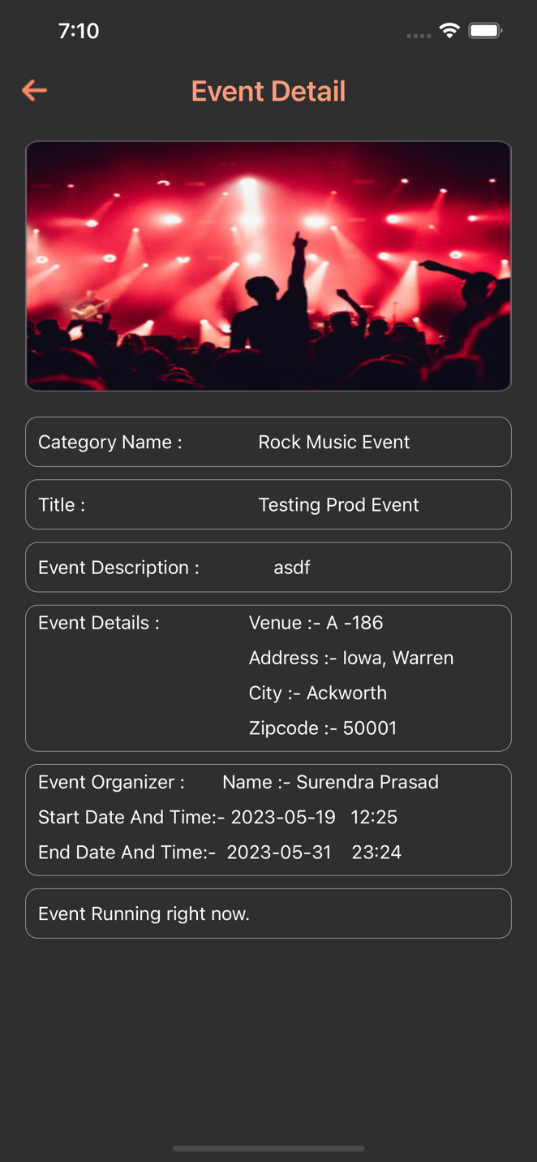

[Figure 4]

### Description

Above is Event detail page of the application. You can see the details of event like start date end date and venue details of event. This scrren shows the event running time,event address event description and start and end date for event.

## Update event Page

### Interface

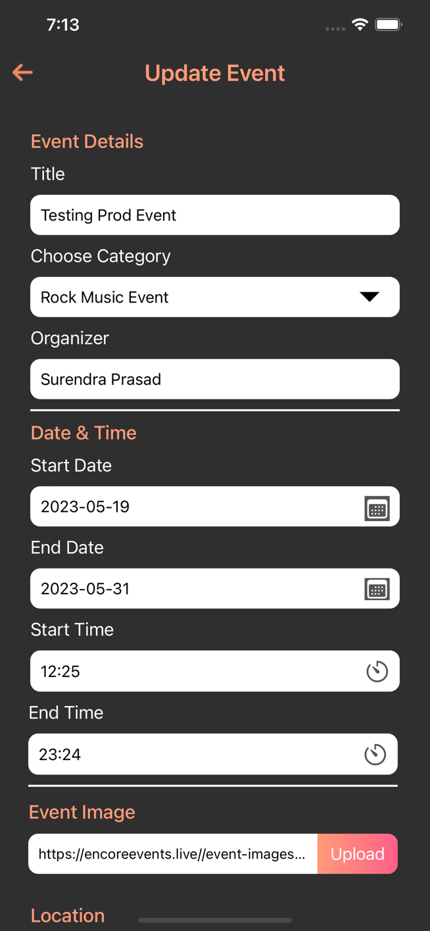

[Figure 7]

### Description

Above is the Update event screen of the application. Here you can update the event details.In this screen all the field is required event is create with or without image. In create event screen we need to enter start date and end date for event.Here we list out all the information like zipcode, address, state, organizer, event title and start/end date.

## Event detail with order Page

### Interface

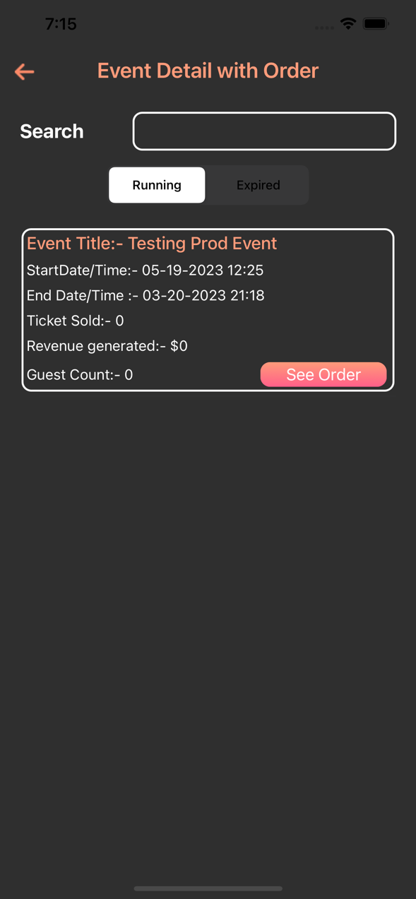

[Figure 7]

### Description

Above is the event details with order page of application. Here you will get the list of running and expire event details and you can also see the order details of event.On see order click we can get the total number of ticket that we purchased.

## Order Detials Page

### Interface

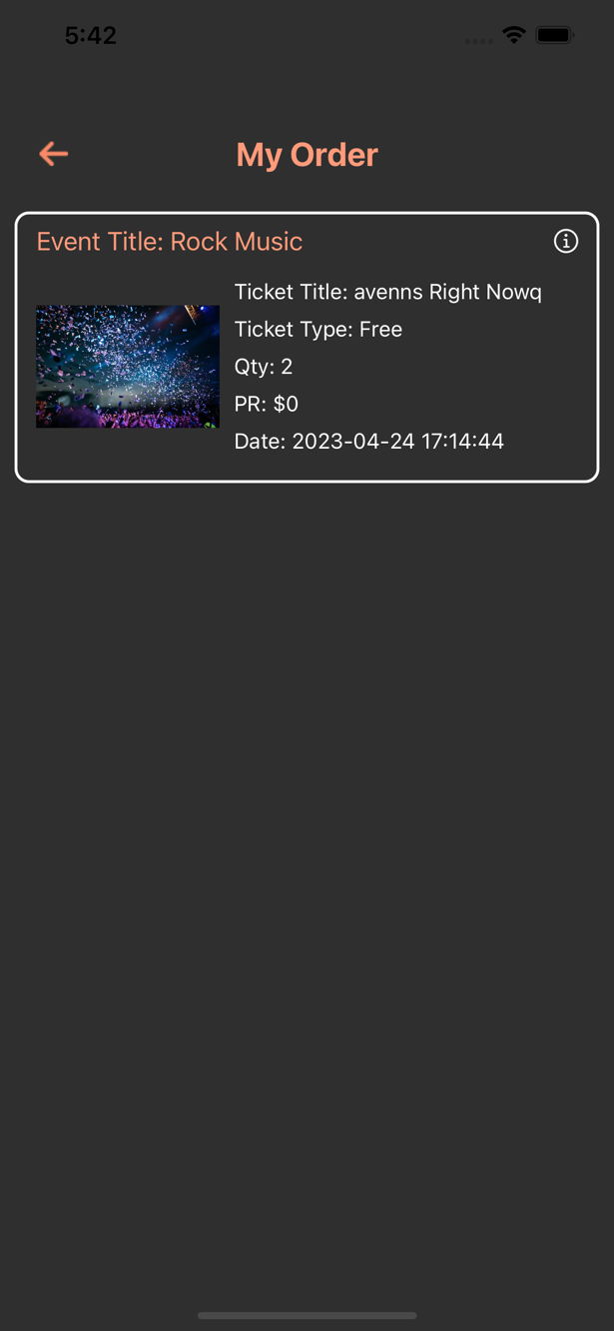

[Figure 7]

### Description

Above is the order details of the application. Here you can see the order details that the user have order here is list of event and price and quantity of ticket in the order details page.On click of Information button you get the ticket details.

## Create Ticket Page

### Interface

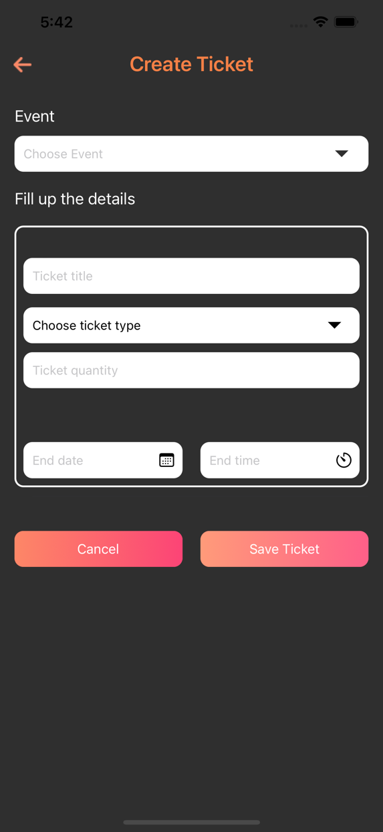

[Figure 4]

### Description

Above is Create Ticket page of the application. Here you can create the ticket for particular event and you can choose the category of event and title of ticket, Pirce, quantity and start and end date of event on click of save ticket you can create a ticket and ticket is showing in manage ticket screen.

## Mangage Ticket Page

### Interface

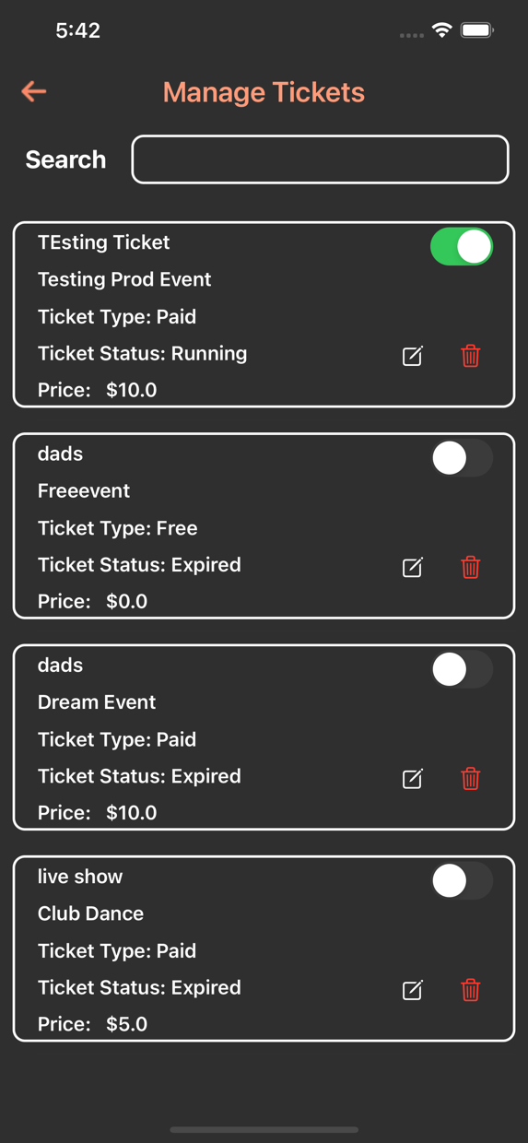

[Figure 4]

### Description

Above is Manage Ticket page of the application. Here you will see the list of ticket and you can change the ticket status if the ticket is unlive you can’t create a event without ticket you are not able to live event. You can delete and update the ticket form this screen.

## Promotional list Page

### Interface

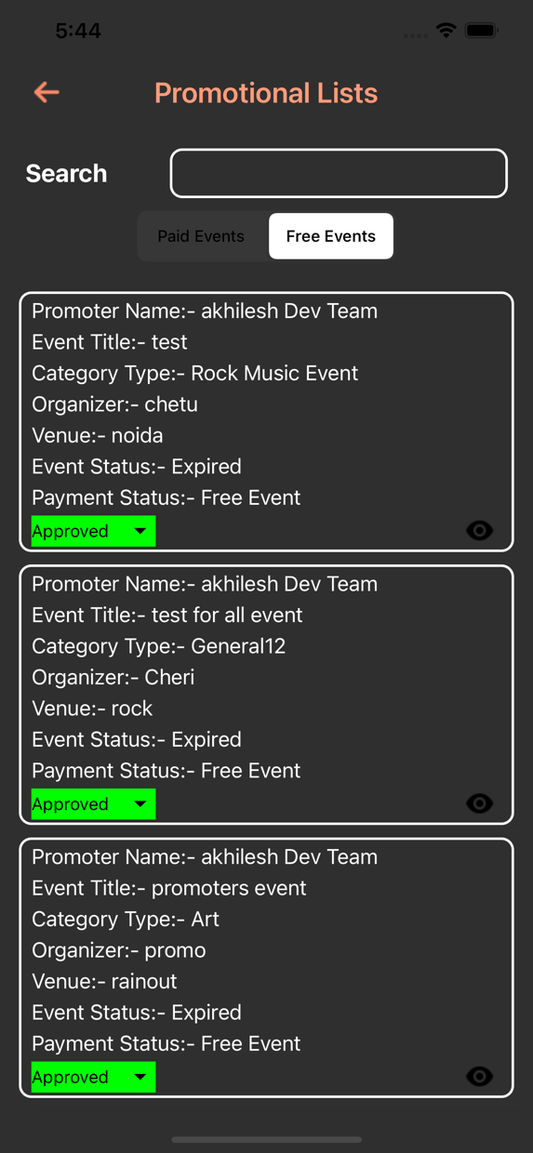

[Figure 4]

### Description

Above is Promotional list Listing page of the application. Here you can find the the event which is created by admin and promoter. This screen is showing the free and paid event details this screen is only for admin and admin can give the access for event eg, Approved, Pending, rejected.

## Subscribed User details Page

### Interface

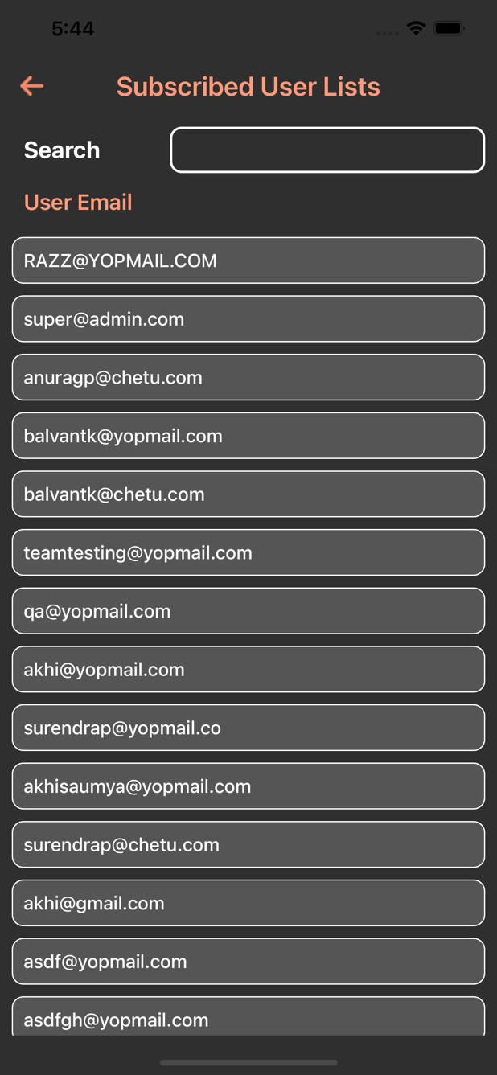

[Figure 4]

### Description

Above is Subscriber user list details of the application. This screen will show the details of the subscribed user who can subscribed for an application.On bottom of screen we added a subscribed user filed so the user can subscribed using their email Id. And the Subscribed user details appear in this list.

## Add Banner Page

### Interface

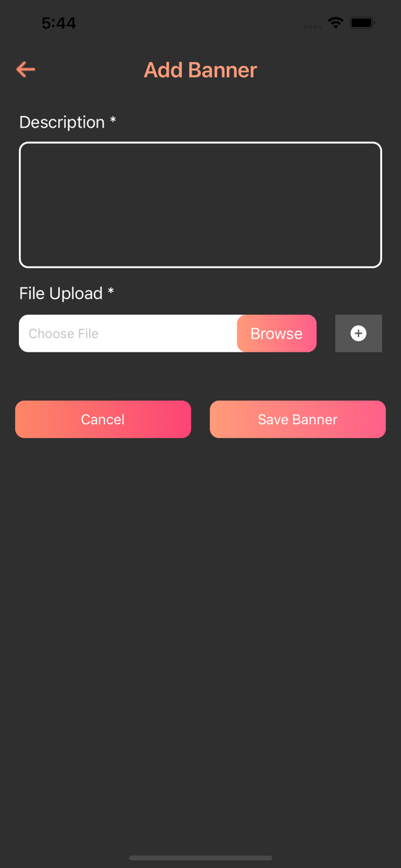

[Figure 7]

### Description

Above is Add Banner page of the application. This is the screen for create a banner for home screen. For creating a banner description and image is required. It is the main part of application.

### Interface

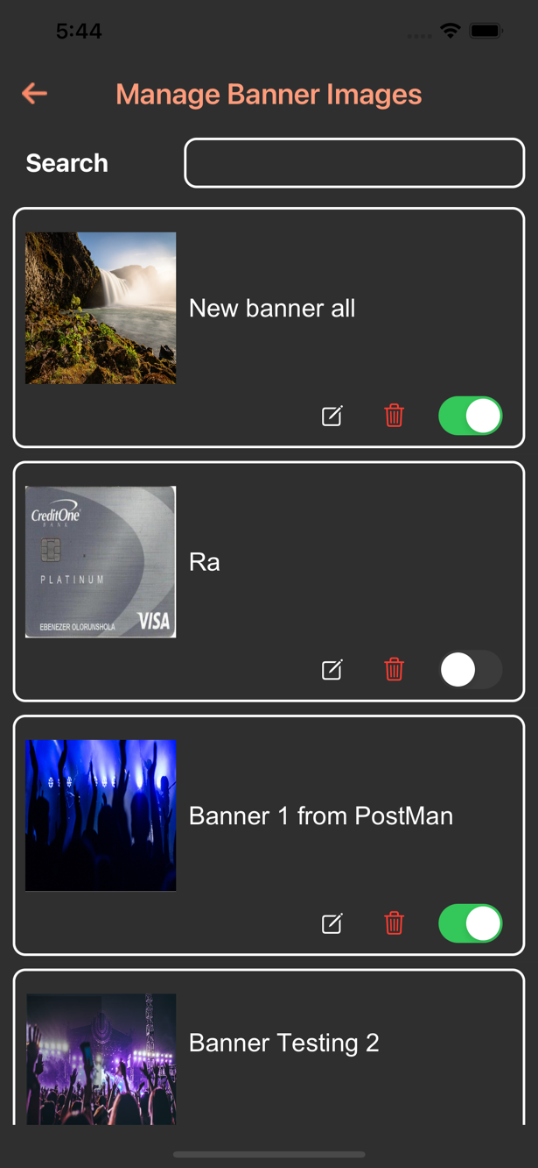

[Figure 7]

### Description

Above is Manage Banner page of the application. Here you will see the list of all the banner details .If you change the status of banner it will reflect on home screen here you can update and delete the banner in manage banner screen. In this screen we showing the banner image and description what we are showing in banner image.

## Scan Ticket Page

### Interface

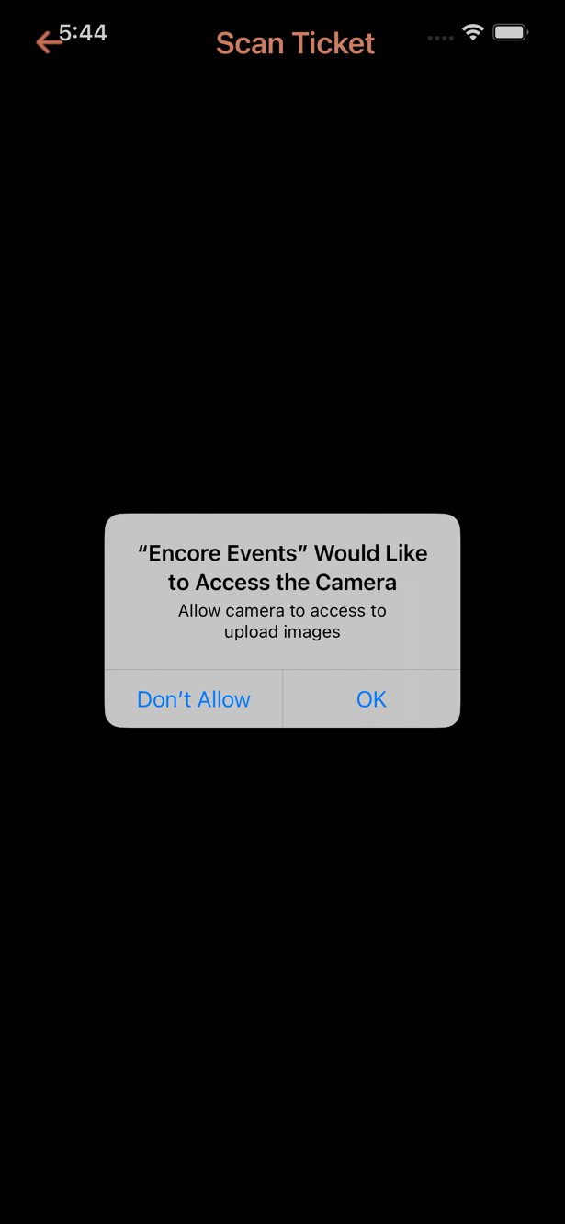

[Figure 7]

### Description

Above is Scanner page of the application. Here you can scan a ticket and after scan a ticket verify the ticket status eg. Wrong Ticket, Guest Arrived, Already scanned. This is the main functionality for application. For scanner we create a ticket QR-Code. After scanned ticket we identify the user detail.we added the functionality the wrong user is not belongs to any event.

## Contact us Page

### Interface

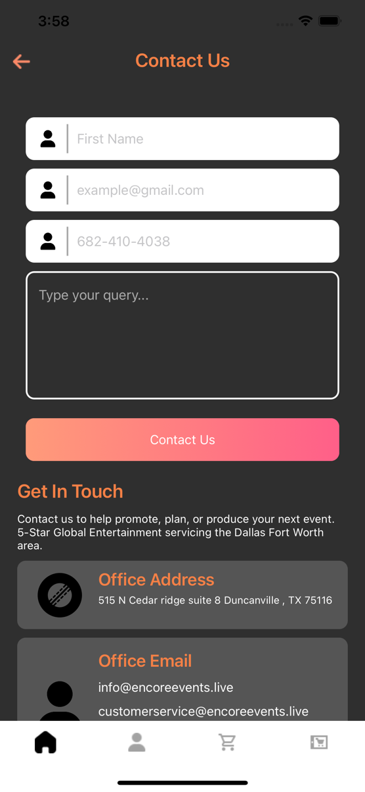

### Description

Above is Contact us page of the application. This screen is used for enquire and contact support for any issue and help regarging application so user can simply enter their name, email, phone number and description what issue are facing after click on contact us button the request is being processed to Admin. Here we also showing the office address and official email.